STATE OF NEVADA
JOE LOMBARDO
Governor

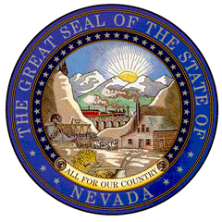
DEPARTMENT OF BUSINESS AND INDUSTRY
DR. KRISTOPHER SANCHEZ
Director

BRETT HARRIS
Labor Commissioner

TONI GIDDENS
State Apprenticeship Director
OFFICE OF THE LABOR COMMISSIONER
NEVADA STATE APPRENTICESHIP COUNCIL
www.Labor.nv.gov

2025 Nevada State Apprenticeship Council Meeting Agenda Item 9

Due to the sensitive information contained in this item, documents will not be posted

